# 

# **Module: GUI Design and Database Connection**

# **Module Code: COMP4604**

# **Course Code: TU819/4**

# **Course Group: Group A/B**

# **Student Names: Jason Leonard & Brian Twene**

# **Student IDs: C19500766, C19344543**

# **Submission Date: 04/12/2022**

# **Topic: Vehicle Dealership/Rental System**

**Module: GUI Design and Database Connection** **1**

**Module Code: COMP4604** **1**

**Course Code: TU819/4** **1**

**Course Group: Group A/B** **1**

**Student Names: Jason Leonard & Brian Twene** **1**

**Student IDs: C19500766, C19344543** **1**

**Submission Date: 04/12/2022** **1**

**Topic: Vehicle Dealership/Rental System** **1**

**Introduction** **2**

Register Page (Customer) 3

Login Page (Customer) 4

Reset Password Page (Customer) 5

Main Menu Page (Customer) 6

Login Page (Admin) 6

Main Menu (Admin) 7

Manage Customers Page (Admin) 8

Manage Vehicles Page (Admin) 10

# **Introduction**

This test record document is based on a software solution for a vehicle dealership which allows a user to both purchase vehicles, rent vehicles and return vehicles when they’re finished using them. Additionally, the program also allows an admin to alter a users and vehicles table which is located within a Microsoft Access database, and allows the admin to add, edit, and remove information from their respective tables. Our application also features stock and inventory control, and allows management to print a list of users and a list of our stock and inventory. Lastly, an admin is also able to use this program to check overdue accounts for people who have not returned their rented vehicle.

## **Register Page (Customer)**

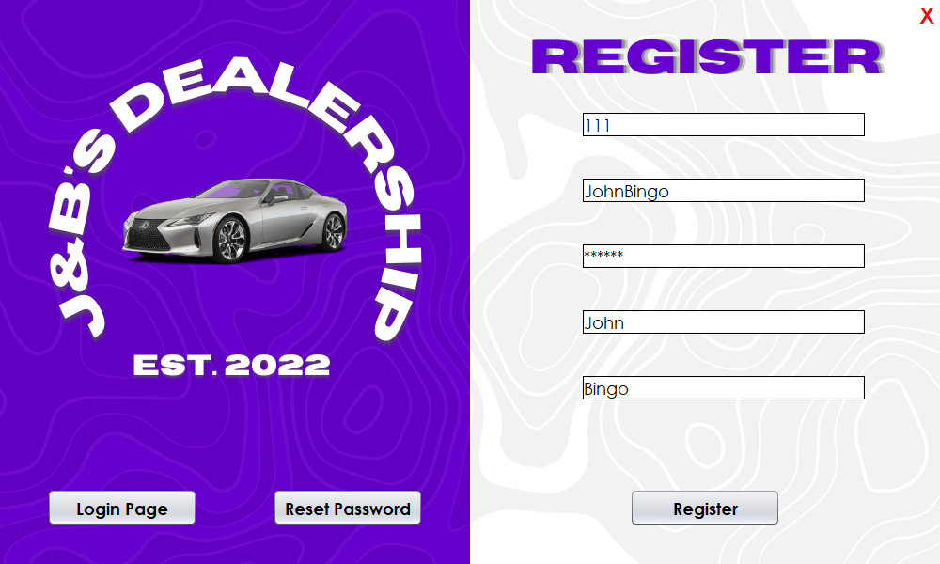

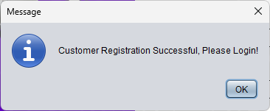

## **Login Page (Customer)**

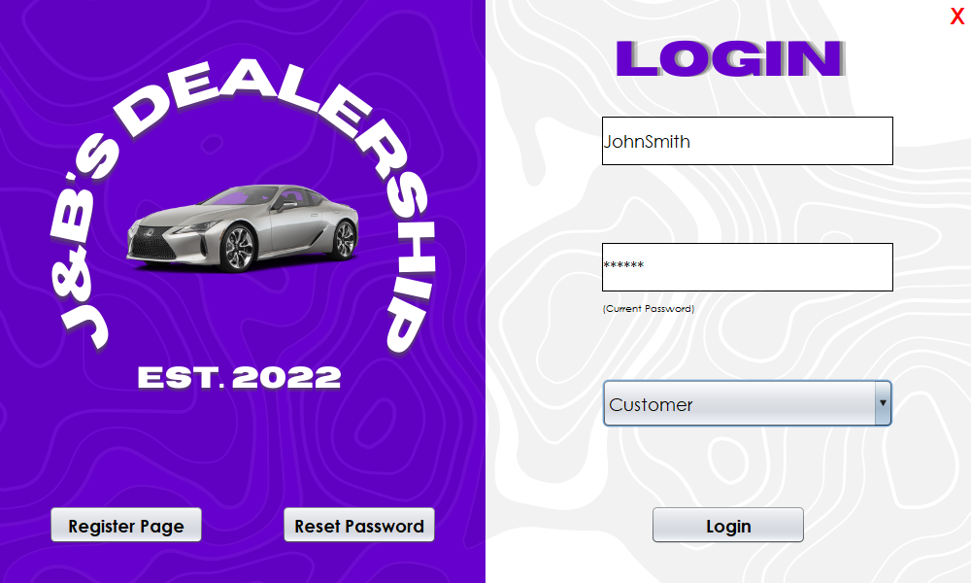

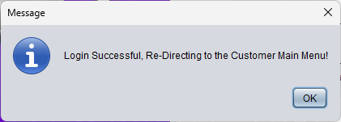

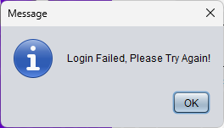

## **Reset Password Page (Customer)**

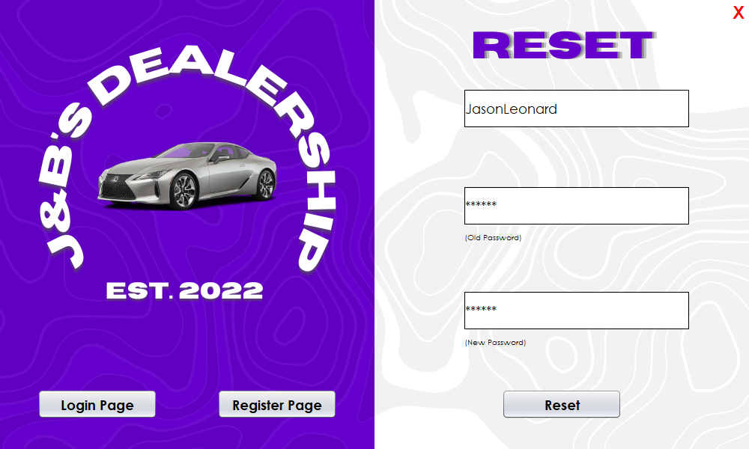

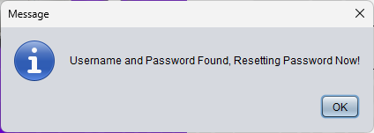

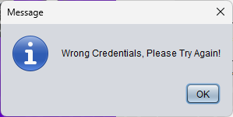

## **Main Menu Page (Customer)**

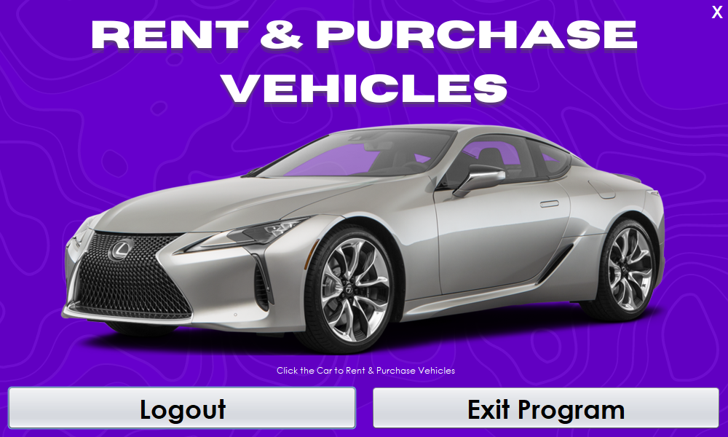

## **Login Page (Admin)**

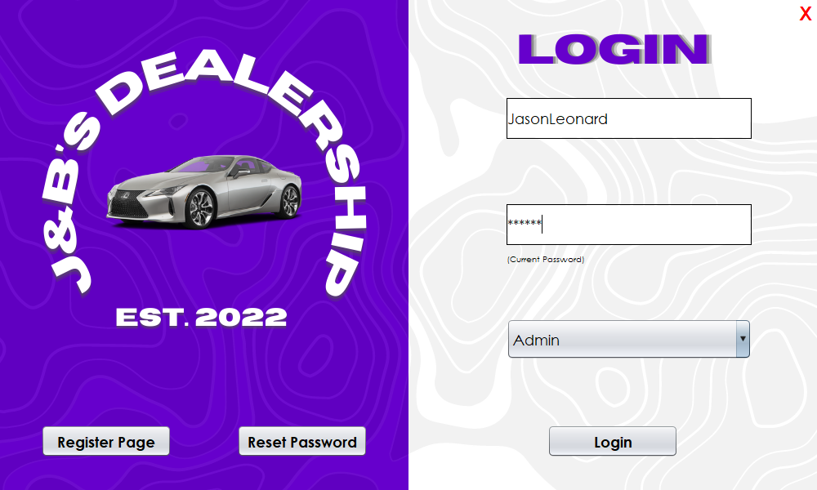

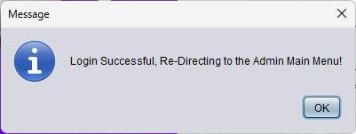



## **Main Menu (Admin)**

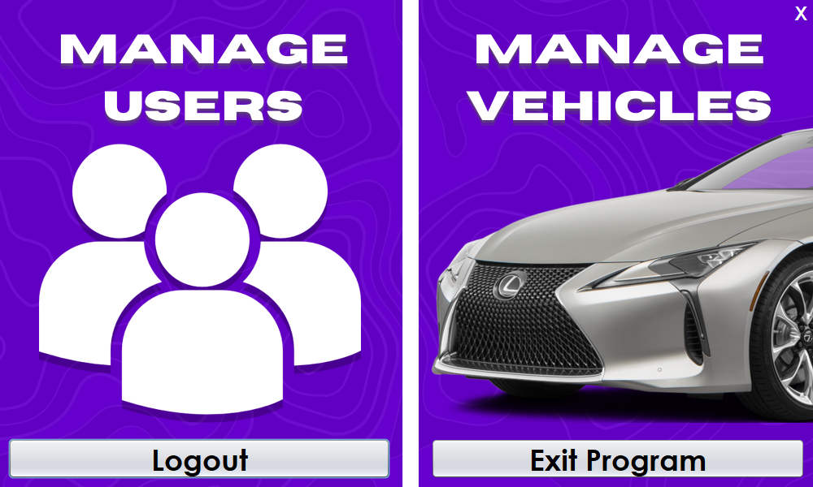

## **Manage Customers Page (Admin)**

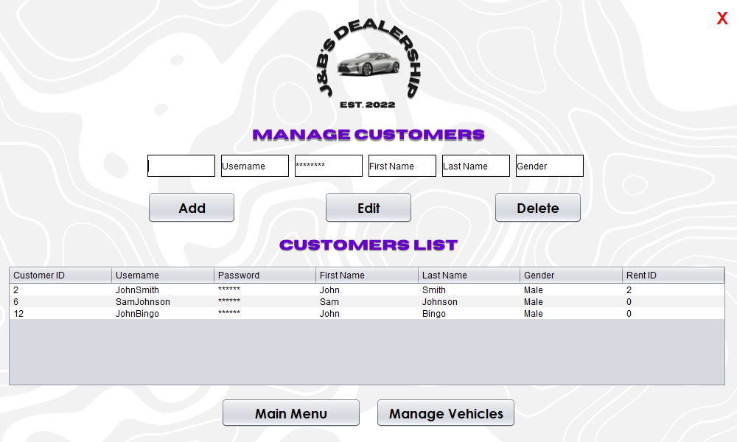

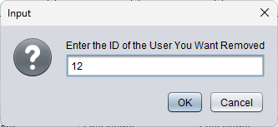

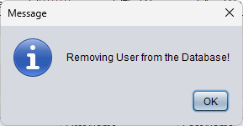

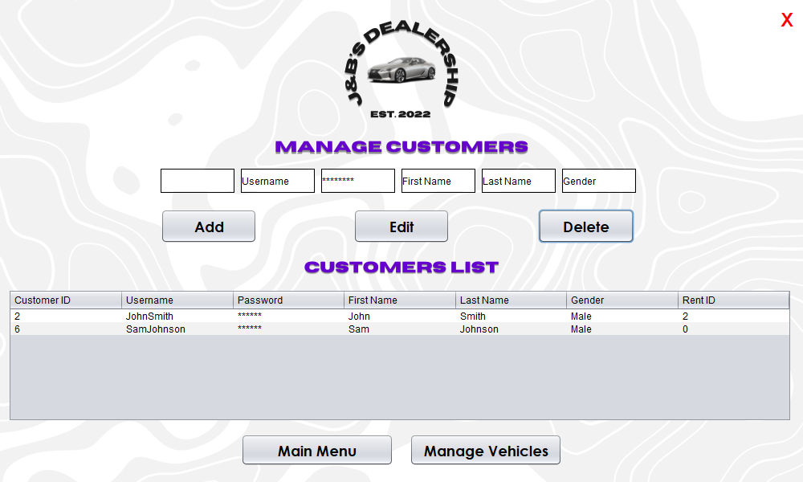

## **Manage Vehicles Page (Admin)**

